

SIMATS ENGINEERING

Saveetha Institute of Medical and Technical Sciences
Chennai- 602105

Student Name: JANANI .B Reg. No.:192521052
Course Code: CSA 0732 Slot: C
Course Name: COMPUTER NETWORKS FOR DATA CENTERS
Course Faculty: Dr.K.SENTHIL
Project Title: Advanced Traffic Modeling and Congestion Management Solutions for Modern Networking Platforms
Module Photographs:
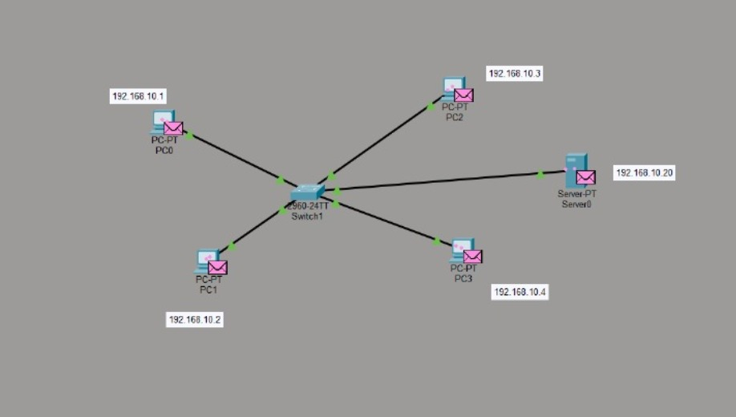
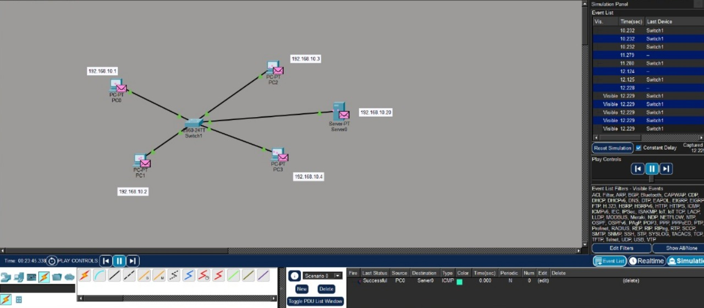
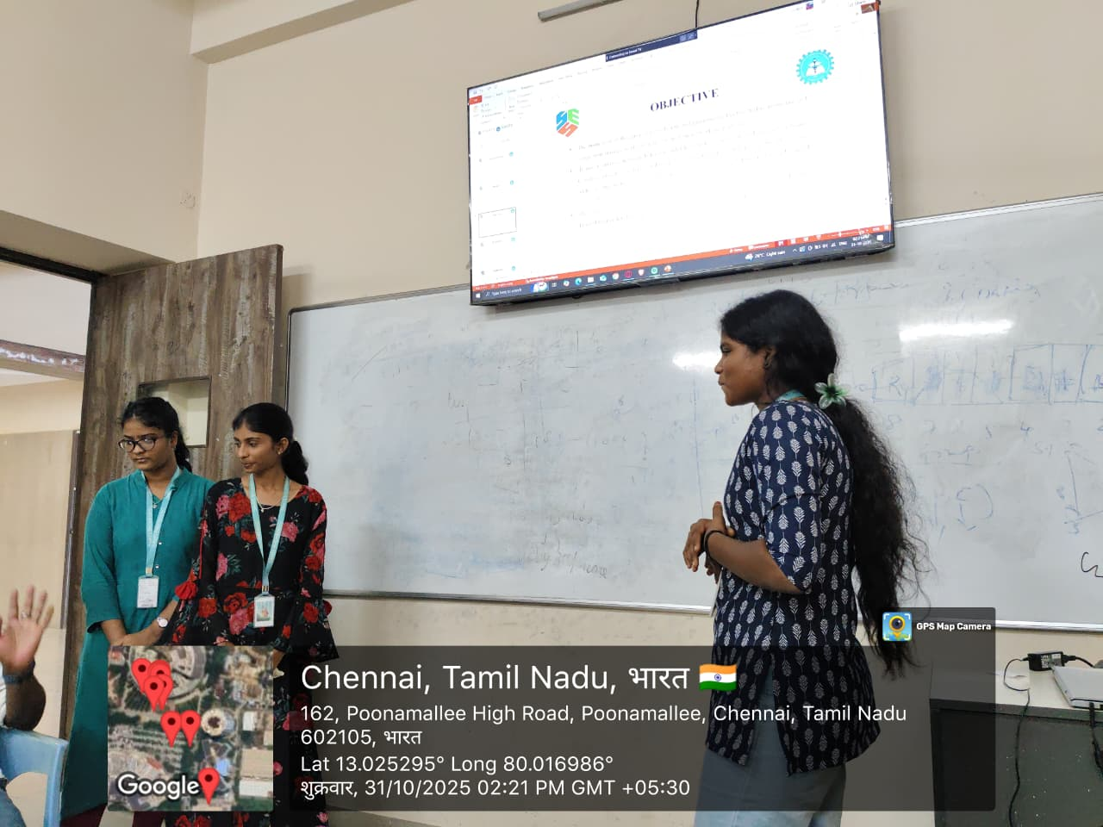
Project Description:
The project “Advanced Traffic Modelling and Congestion Management Solutions for Modern Networking Platforms” focuses on understanding and improving network performance through three key modules. Module 1: Network Traffic Analysis deals with studying data flow patterns, identifying traffic behaviour, and detecting causes of congestion. Module 2: Congestion Management Strategies explores various techniques like traffic shaping, load balancing, and queue management to control data flow and reduce network delays. Module 3: Network Congestion Management Testing involves implementing simulations and performance tests to evaluate the effectiveness of these strategies in real-world scenarios. Together, these modules aim to develop efficient, reliable, and scalable solutions for modern network environments.

Student Signature Guide Signature

